

Summary of responses to the ‘Consultation on draft panel criteria and working methods’

March 2012

Introduction

- From the end of July to 5 October 2011, we consulted on REF 03.2011 ‘Consultation on draft panel criteria and working methods’ (July 2011), including the statements of criteria for the four main panels, and the statement of generic criteria (in particular, the arrangements for individual staff circumstances). We received 399 responses, broken down as follows (although many respondents responded only to a few questions):

Higher education institution (HEI) | 168
Academic association or learned society | 92
Professional, government or charity/third sector organisation | 27
Other | 112

- This summary outlines the key issues raised during the consultation about both the panel criteria as a whole, and each of the main panel criteria statements individually. It also includes graphs showing responses to a number of closed questions asked in the consultation.

- A summary is provided at Annex A of four workshops that were held during the consultation exercise to engage users of research.

- In January 2012 we published REF 01.2012 ‘Panel criteria and working methods’ (January 2012). The publication sets out the final panel criteria and working methods for the assessment, which were refined in light of the consultation responses summarised in this document.

Responses to the generic statement of criteria

- There were 395 respondents to the generic statement of criteria.

Consistency between the main panel criteria

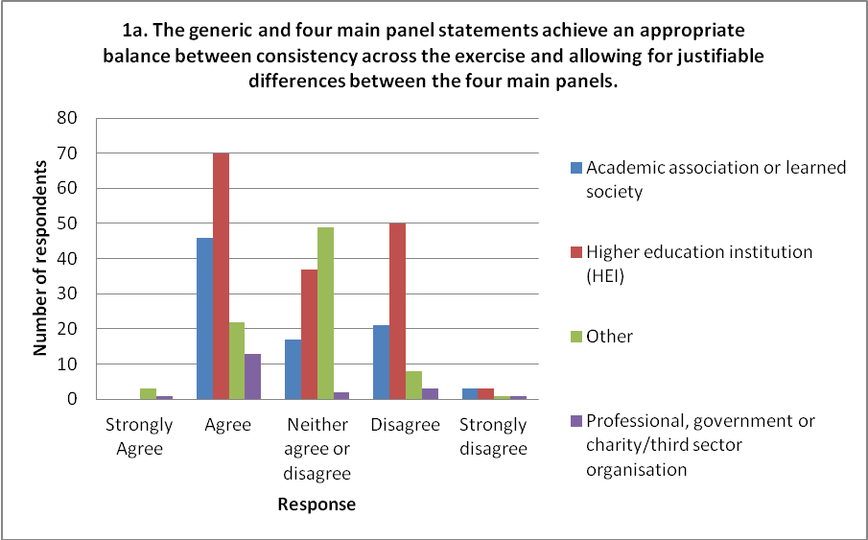

- Many respondents welcomed the move to greater consistency and the general level of consistency achieved across the four main panels. Many (including those that welcomed the move to greater consistency) suggested particular areas where they would favour greater consistency, or at least requested clearer justification of the differences between main panels. Broadly, reasons outlined for wanting greater consistency included:

- A less burdensome approach and more transparency for institutions in preparing submissions across a range of units of assessment (UOAs).
- Where work crosses main panel boundaries, consistency across panels reduces the need for tactical decision-making about where to submit such work.

- Many responses raised the main panels’ approach to double-weighted outputs and to co-authored outputs as particular areas where further consistency would be welcomed.

  - Double-weighting: many highlighted this issue as one where greater consistency would be desirable, although respondents did not collectively propose a common solution. The most common suggestion was for all main panels to accept reserve outputs, with several in favour of consistency regardless of the approach taken. Several stressed the importance of consistency between Main Panel C and Main Panel D in particular. A few also requested clearer criteria for what would count as double-weighted.

  - Co-authorship: many respondents queried the four different approaches to listing co-authored outputs set out by the main panels. Most of the respondents on this issue favoured either clearer justification of the differences or greater consistency of approach. A few highlighted the need for consistency between Main Panel A and Main Panel B in particular, with some expressing concern about the burden involved in Main Panel A’s approach of requiring information about the author’s contribution for all co-authored outputs.

- The following issues were also raised by significant numbers of respondents and are ordered to reflect the frequency with which they arose:

  - Additional information requirements for outputs: greater consistency was favoured in the requirements for additional statements about outputs, or at least consistent word limits where statements were requested.

  - Language: preference was expressed for the main panel statements to use the same wording where the same meaning is intended, to avoid the need to interpret whether different wordings imply material differences in the criteria. Some also requested a standard structure and headings, and the removal of repetition from the ‘Assessment framework and guidance on submissions’.

  - Multiple submissions: respondents on this issue felt the approach across main panels should be more consistent. Some commented specifically that UOA3: Allied Health Professions, Dentistry, Nursing and Pharmacy should permit multiple submissions to allow the reporting of results for the distinct disciplines it covers. Several requested that decisions on allowing multiple submissions should be taken earlier to reduce uncertainties in planning.

  - Cross referrals and interdisciplinary research: a number of issues were raised about cross-referral. Points included a desire for more consistency in the approach, more clarity on how the process will work in practice (for example, where the assessing panels employ different criteria or procedures), or a desire to ensure that work on the boundaries between two UOAs should achieve the same score regardless of the panel to which it is submitted.

  - Guidance on the range of impact and evidence: more detailed guidance was sought from Main Panel C on the range of impact in the disciplines covered by this panel, in line with the other main panels. Some respondents noted the desire for a more consistent level of detail between main panels without specifying in what way.

  - Environment template: it was felt that the main panels should have more consistency in the weightings given to the environment sections, or justify these differences; some noted that Main Panel C in particular should state what weightings will be used for the environment sections.

  - Outputs criteria and level definitions: the differences of style, meaning, concepts and level of detail were highlighted in the output criteria and level definitions provided by the main panels. Greater consistency was favoured, particularly given that some work is on the boundaries between main panels and should be assessed against broadly the same criteria.

- The remaining issues below, though raised less frequently, were raised by a significant minority of respondents:

  - Citation information: a number of specific points were made about citation data; a number of respondents sought further clarification on its use and contextualisation, while a few questioned the use of Google Scholar by Sub-panel 11: Computer Science within the arrangements set out in the ‘guidance on submissions’.

  - Underpinning research for impact: a few suggested that there should be a more consistent approach to assuring the underpinning quality of research for impact case studies, or requested more clarity (from Main Panel A and Main Panel B in particular) about the kinds of evidence required.

  - Impact criteria: a few respondents wanted clearer or more consistent definitions of the impact criteria, or sought further information on how they would be applied in the assessment.

  - Environment data: a number of respondents requested clearer justification of the additional data requests – particularly in Main Panel B – with a few suggesting they be removed, and some raising concerns (for example, about burden or the limitations of such data) or stating that a clearer definition should be provided for any such requests.

  - Working methods: several respondents raised points about mechanisms to achieve consistency between the main and sub-panels, and the importance of international benchmarking, but no common suggestions were made.

Individual staff circumstances

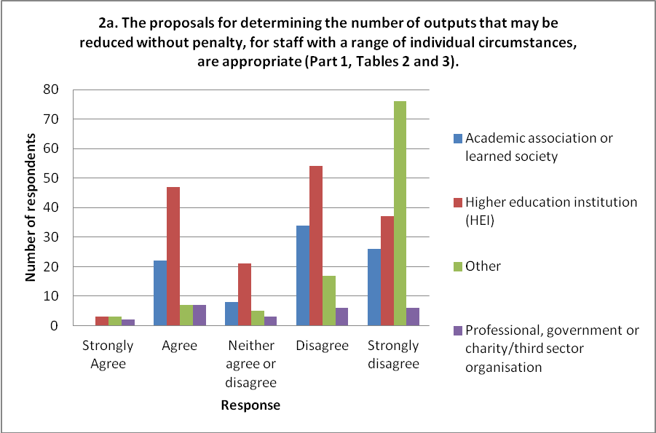

- Many respondents supported the clear, consistent approach and/or the role of Equality and Diversity Advisory Panel (EDAP) in dealing with individual staff circumstances in the REF. Many supported the view that the ‘tariffs’ should be consistent across the exercise, while a few noted the impact that different publication practices may have in different disciplines.

Maternity/paternity/adoption leave

- An overwhelming majority of respondents supported or strongly supported the reduction of one output for each period of maternity leave. Many said this should be regardless of the length of the period of leave. A number also raised the question of paternity or adoption leave, with many of these suggesting these circumstances should be treated equitably. Several also noted that the option should remain open to request additional dispensation for particularly constraining cases, through the ‘complex’ route.

Tariffs

- Many respondents felt the tariff for clearly defined circumstances too stringent, with several suggesting that an absence of 9 or 12 months merits the reduction of an output. Several felt the tariff appropriate. A number of respondents found the tariffs complicated to understand.

- Many felt the tariff for early career researchers (ECRs) appropriate, while a few felt it should be more generous. Several requested clarification of the definition of ECRs.

Complex circumstances

- Several respondents suggested that complex cases should be considered in advance of the submissions deadline or that reserves should be allowed, to avoid institutions being overly cautious with such cases. A few urged that the worked examples of complex circumstances to be published by the Equality Challenge Unit should be made available as soon as possible.
Responses to Main Panel A’s statement of criteria

- There were 141 respondents to Main Panel A’s statement of criteria.

Consistency across sub-panels and consistency of assessment

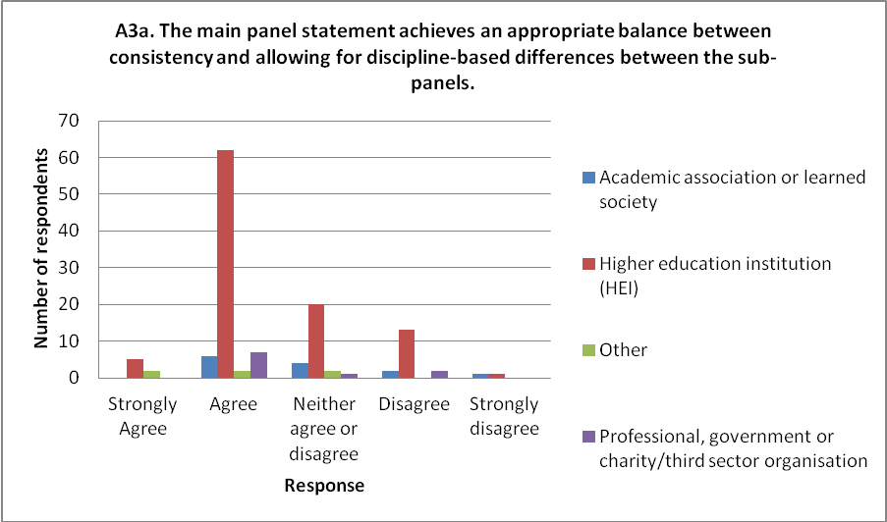

- Of those commenting, the tension between achieving consistency of approach and recognising discipline-based variation was a common theme. Comments were clustered around:

- UOA 3: Allied Health Professions, Dentistry, Nursing and Pharmacy, due to the scope for very diverse submissions in this UOA. Respondents raised issues relating to appropriate numbers of assessors with the right subject expertise (insufficient biomedical and dental member numbers being raised explicitly) and to mechanisms to ensure consistency of judgement.

- Recognition of effects of significant overlap between the sub-panels and how consistency of assessment and comparability of outputs would be achieved.

- Requests for sub-panels to be allowed to vary an approach on certain grounds: respondents suggested that UOA 3 should be able to adopt a different approach to the use of citation data; the need for difference in assessment of significance and reach for UOA 2 (Public Health, Health Services and Primary Care and UOA 3 was highlighted, and some felt that the output criteria may need to vary as a 4* in one subject may look different to a 4* in another).

- Requiring more information on how sub-panels will work, especially the calibration exercise, how consistency will be achieved in practice, and use of expertise in reviewing outputs.

Submissions and UOAs

- The majority of respondents either did not comment or were supportive of the guidance on UOA descriptors and boundaries. A few respondents raised a number of specific points, including clarification about submitting pedagogical research and the coverage of UOAs 3 and 4. Some observed that additional assessors in specific areas would need to be appointed.

- A considerable majority of respondents either did not comment or were supportive of the guidance on multiple submissions. Of the respondents who suggested changes, nearly all related to UOA 3 where a preference was expressed for the acceptance of multiple submissions in line with the ‘guidance on submissions’.

Outputs

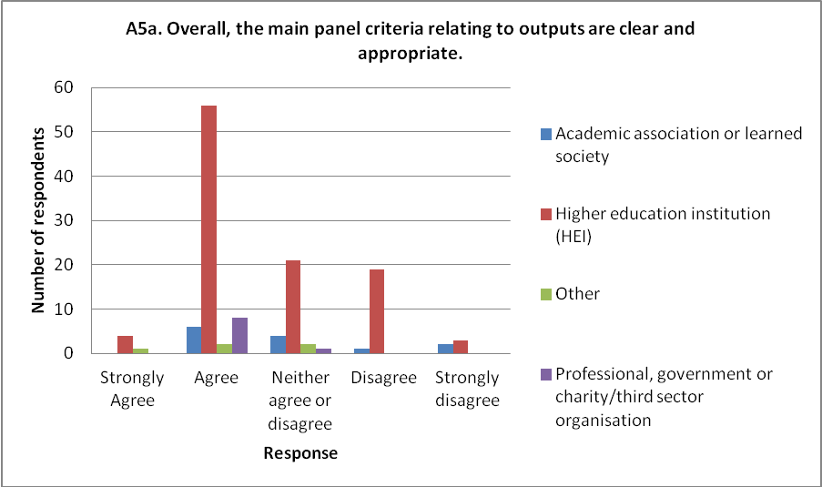

- Most respondents confirmed that they considered the output criteria in Main Panel A to be appropriate. Where comments were raised, the majority focused on co-authored outputs, double weighted outputs or the use of citation data. A number of respondents also suggested that Main Panel A adopt Main Panel B’s starred-level definitions and descriptions in relation to outputs.

  - Co-authored outputs: there was widespread concern amongst respondents about the requirement for up to 50 words defining the author contribution for all co-authored outputs. Reasons included: the text will be un-auditable; it will apply to a high volume of outputs (as a large majority are co-authored in the disciplines covered); the burden on HEIs; a discouragement to collaborative working; the effect on behaviour. A number of respondents suggested Main Panel A adopt the same approach as Main Panel B in relation to co-authored outputs. If the requirement is retained, respondents requested greater clarity about what is meant by ‘material’ contribution. Respondents also expressed concern about the high penalty for submitting an output twice within the same submission if each author’s contribution was not judged sufficient.

  - Double-weighted outputs: the majority of respondents that commented on double-weighted outputs expressed concern about the inconsistency in approach across the main panels. It was felt that the inconsistency of approach is not justified and the penalty for HEIs in making a wrong judgement about the scale and scope of an output is high and/or prohibitive. Almost all who commented recommended that reserve outputs should be allowed. A few respondents requested greater clarity about what is meant by ‘scale and scope’.

  - Citation data: a range of comments were made on the use of citation data. A number of respondents were satisfied with the criteria as currently drafted. Other respondents welcomed the cautious approach, but requested further clarification or information in the criteria. Some respondents expressed concern about the use of citation data, as given the number of caveats stated in the draft criteria about its use, citation data should not be used to inform the assessment of research outputs. Some concerns included the issue of self-citation and the equality implications. A few respondents commented that the use of citation data in Nursing (in UOA 3) is inappropriate and that the UOA should have distinct criteria to allow for its use.

Impact
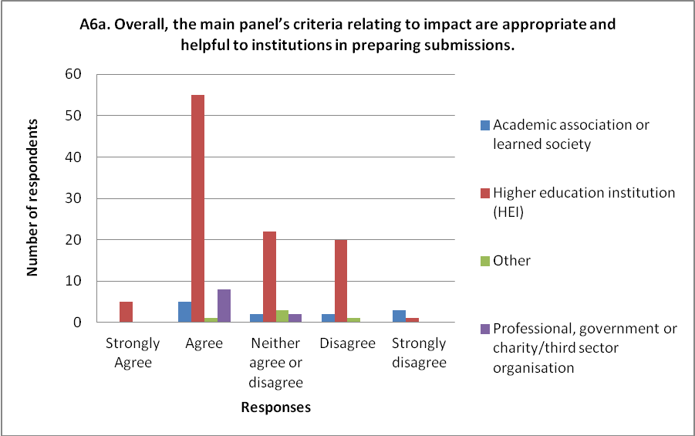

- The majority of those who commented on the impact criteria raised issues concerning the underpinning research within impact case studies. Many HEIs requested further information regarding the 2* threshold for underpinning research, primarily relating to how this threshold will be assessed and how many outputs needed to be 2* quality. Respondents also wished for clarification on the assessment of a unit’s contribution to impact (claimed by multiple units). A small number of HEIs queried whether allowances should be made for new units (departments), whether the period for underpinning research should be extended, or whether research undertaken at a previous institution could be included as underpinning research.

- Many respondents requested a more detailed definition of reach and significance; a small number suggested using definitions provided by either Main Panel B or Main Panel C. A small number also requested clarification on the requirement to demonstrate reach and/or significance holistically, and further details on the level definitions.

- Several other comments were made on impact. Several stressed that all types of impact should be considered equal; a small number sought further clarification on the use and nature of evidence in case studies; and a small number requested more detailed guidance on completing the impact template.

Environment

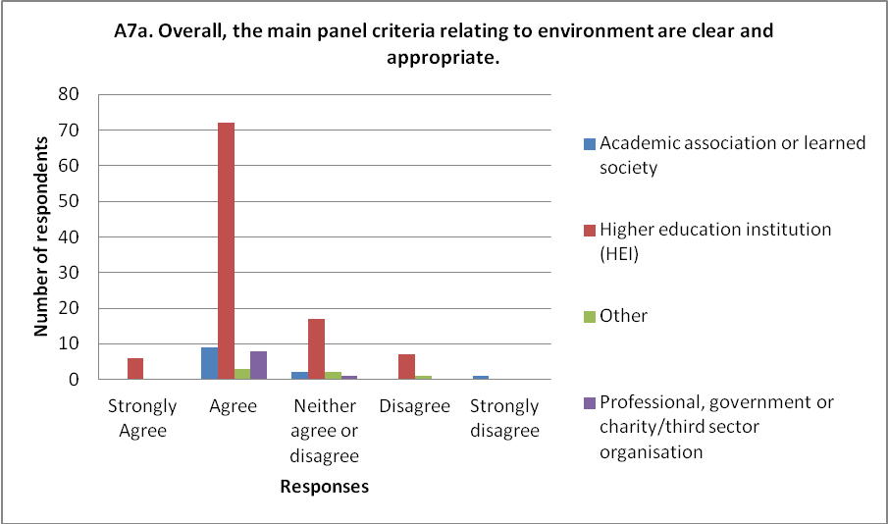

- Around half of respondents made no comments regarding the environment, or agreed with current draft statements. The issues raised most frequently by the remaining respondents were:

- Describing and assessing the research environment across disparate research groups. Respondents raised concerns about the practicalities and the space provided within the environment template to describe multi-disciplinary and diverse research groups, especially in UOA 3.
- The criteria of vitality and sustainability, and the development of the sub-profiles. Respondents suggested the criteria should be more clearly defined. They also sought greater clarity on how they will be applied, on the weightings of the environment template, and further consistency across main panels on these issues.
- The definition of research student activity within HESA data (whether this included professional doctorates, masters research students), and omission of data for the first year of the assessment period. It was felt that this was inconsistent with previous RAEs, and considered that the gap in data would be significant for some institutions.

- A small number also raised comments on:

- proportionality in taking account of the environment descriptors (for example, for new units, very diverse research groupings)
- consistency of assessment and value of esteem markers
- support for not requesting additional quantitative information.

Working methods

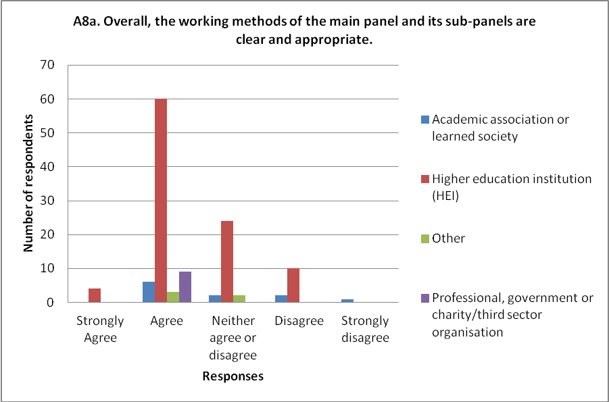

- The majority of respondents made no comments regarding the working methods. A small number of respondents raised comments on the following:

- A sufficient number of assessors will need to be appointed to ensure appropriate assessment across the broad and potentially disparate UOAs.
- The cross-referral approach may discourage inter-disciplinarity.
- Further information was sought on the calibration exercise.
- Further information was sought on the mechanism for allocating outputs (a small number requested that all outputs should be read by at least two sub-panel members).

Responses to Main Panel B’s statement of criteria

- There were 126 respondents to Main Panel B’s statement of criteria.

Consistency across sub-panels and consistency of assessment

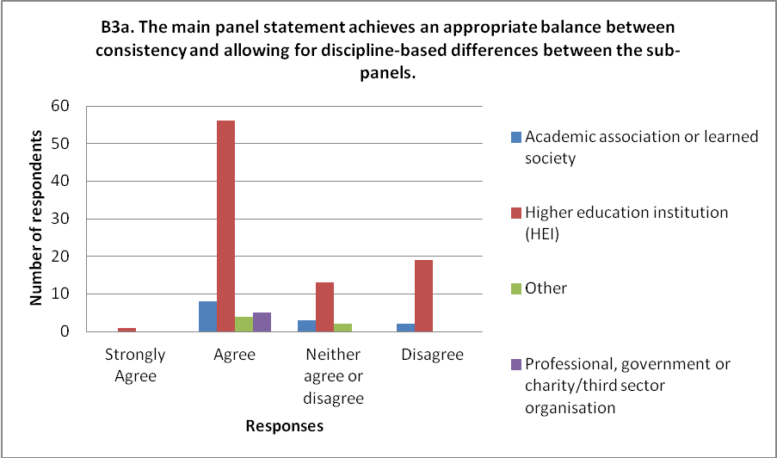

- A large proportion of respondents made no comment or re-iterated points also made under specific sections. A number of respondents specifically noted that the level of main-panel consistency was appropriate, with some commending the main panel’s approach as justified and appropriate.

Submissions and UOAs

- More than half the respondents on multiple submissions provided positive feedback that the arrangements were appropriate or reasonable or justifiable on a disciplinary basis. Of the others a minority:

- suggested that multiple submissions should be allowed in more UOAs
- felt that the sub-panel variation was not justified.

- We received a number of specific comments on the UOA descriptors.

Outputs

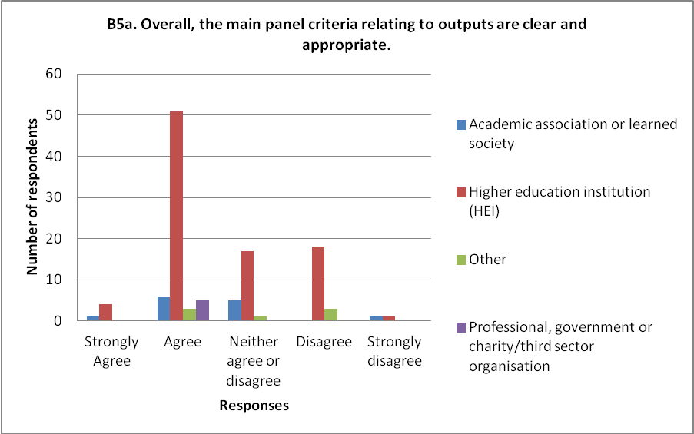

- The largest number of comments on outputs related to the use of citation information, followed by co-authorship arrangements and double-weighting.

- Co-authored outputs: regarding the information requested in UOA9: Physics only, respondents raised strong concerns about the definition of ‘significant’, and the threshold being set at 5 co-authors (which many felt was too low). A minority of respondents welcomed this requirement. A number of respondents suggested that Main Panel B should accept the same co-authored output more than once in the same submission, to provide consistency with other main panels.

- Double-weighted outputs: respondents expressed a clear unease that Main Panel B would not allow the submission of reserves due to the penalty for a rejected double-weighting request. A small number of respondents also sought further clarification of the criteria for double weighting.

- Citation information: a significant number of respondents expressed strong concerns at the potential lack of transparency and equality in the use of Google Scholar by UOA11: Computer Science and Informatics. This included concern at the lack of opportunity for verification in the same way as proposed for the Scopus data. The consensus view was that this source of data should not be used, but it was suggested that if it were used, then much clearer guidance should be provided on how the sub-panel will generate and use the data. A significant number also questioned the different approaches by Main Panel B sub-panels. There was no consensus view on how consistency might be achieved, but requests were made for justification of the approach taken. A smaller number of respondents sought clarification on the use of citation data and the nature of the contextual information.

- A small number also raised comments on:

- The differences across the main panel in requesting additional information. Respondents suggested that arrangements should either be consistent across all sub-panels or the differences of approach justified on a disciplinary basis.
- Outputs with material in common. Clarification was sought on the guidance provided.

Impact

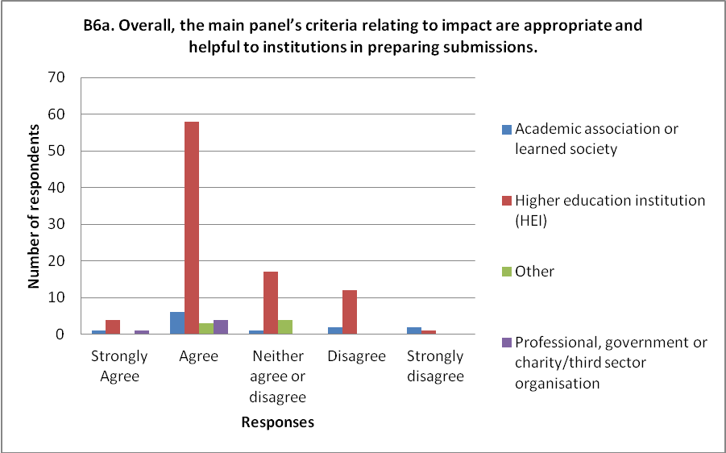

- Comments on impact most frequently addressed the underpinning research, in four main areas:

- Clarification on aspects of the rules for the eligibility of cases studies, relating to the underpinning research (as set out in the ‘guidance on submissions’).
- Further clarity on how the quality of underpinning research will be assessed.
- The timescale for underpinning research – a small minority suggested this should be extended for specific UOAs.
- Emphasising the importance of impact, especially to theoretical subjects such as mathematics, that is achieved indirectly through informing research in another submitted unit. Further guidance was sought on this and the way such impacts will be assessed.

- Respondents were highly supportive of the main panel’s approach to describing the types of impact it anticipates, and the examples of types of indicators. Some respondents sought clarification on a number of points concerning the types of impact. A small minority raised concerns about the indicators, including whether citation data could be used as evidence of impact, and that some were a little vague.

- A small number of respondents also raised comments on:

- the processes for commercially sensitive and highly sensitive impacts
- the requirement for research to be ‘directly connected’ to the impact arising from public engagement
- further guidance on the impact template, including how the panel might take new units into account
- clarification on how the sub-panels would assess reach and significance holistically, and more detail on the interpretation of the level definitions.

Environment

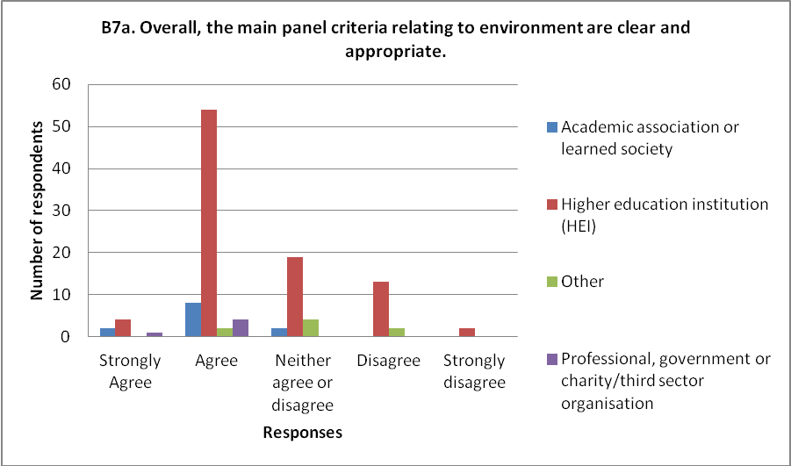

- More than half who commented on the environment criteria raised issues concerning the additional environment data. Respondents queried the rationale for the additional quantitative data requested by some sub-panels in relation to research assistants, research students and research support staff, and how this data would be audited. The key issues highlighted were:

- discipline-specific justifications for the requests have not been given
- the value that such additional data would provide to the panel’s assessment was not clear, and there was concern that the added-value was not commensurate with the additional burden placed on institutions in preparing the data
- the panels had not explained how the additional data would be used.

Working methods

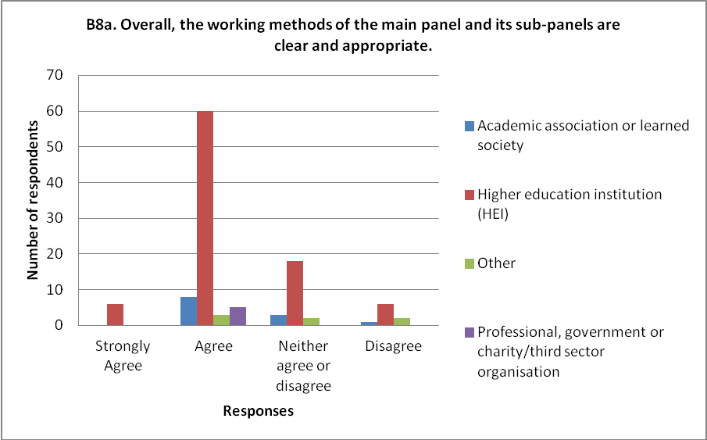

- Around half of respondents on the working methods either had no comments to make or expressed satisfaction with the draft and gave no further comments. The main area of concern raised by respondents was the need for the appointment of sufficient assessors. Respondents sought reassurance that sub-panels would appoint, and would be able to appoint, sufficient assessors to achieve a robust coverage of the subject areas within the UOAs, with a number of comments relating to UOA10: Mathematical Sciences.

- There were a range of other comments from small numbers of respondents in a number of other areas, including the use of cross-referral, use of citation data, and a general request for more detail to be given on the working methods.

Responses to Main Panel C’s statement of criteria

- There were 168 respondents to Main Panel C’s statement of criteria.

Consistency across sub-panels and consistency of assessment

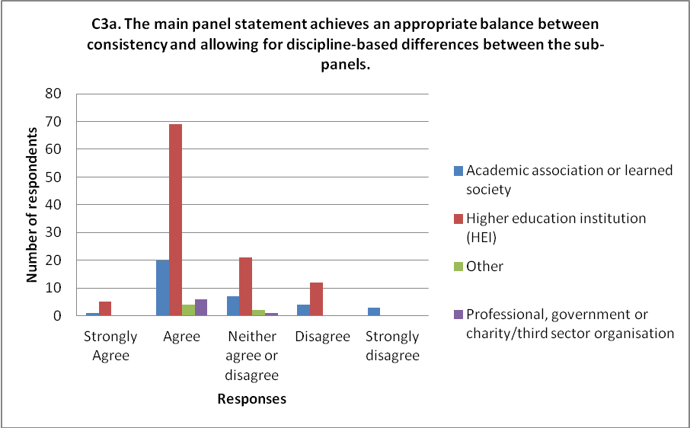

- Overall, the responses welcomed the level of consistency achieved.

Submissions and UOAs

- The majority of respondents either welcomed Main Panel C’s criteria on multiple submissions or had no specific comment to make. Several commented that the timetable for decisions on multiple submissions is too tight, and earlier decisions would be preferred to give institutions greater planning time.

- A number of specific comments were received on the UOA descriptors.

Outputs

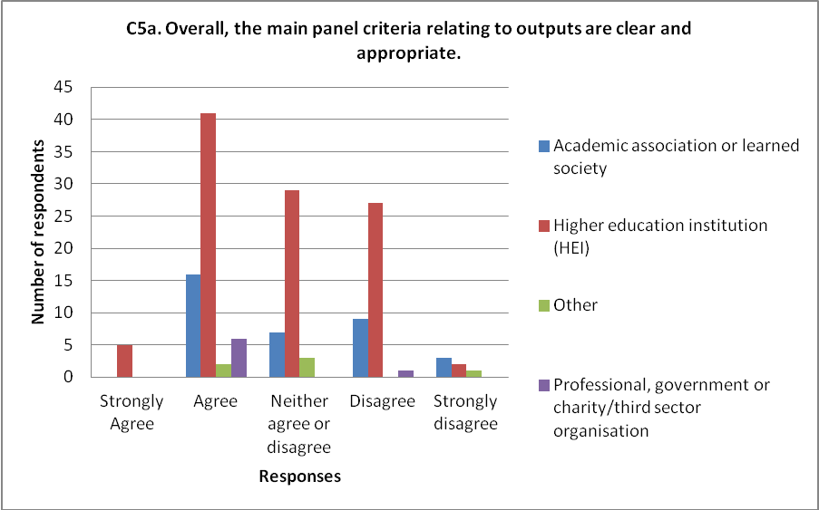

- The issue most raised by respondents concerned the relationship between the assessment criteria and level definitions given in the ‘guidance on submissions’, and the additional information provided in Main Panel C’s criteria statement. In particular respondents expressed concern about how the two would be used together. The following points were raised:

- Subject to clarification of how the two sets of level definitions will be used, a majority felt that the provision of additional detail was useful. A small number highlighted that they felt the definitions provided by Main Panels B and D were more helpful in this respect than those provided by Main Panel C.
- A small minority felt that the definitions in the ‘guidance on submissions’ were sufficient and that the additional gloss from the main panel did not add anything.
- Many respondents raised concerns that the distinction between 2* and 3* was not sufficiently described, in view of the importance of the boundary.
- Many respondents disliked the usage of ‘setting agendas’ in the level definition for 4*. This was seen as both too difficult to assess and had the effect of privileging significance over originality and rigour.

- A number of suggestions were received in response to the request for forms of output which do not represent the published version of the work, including:

- interim fieldwork results in archaeology
- working papers and discussion papers
- short papers and abstracts in conference proceedings.

- There was a strong consensus (particularly in Economics and Econometrics) that working papers that appeared in the public domain before 2008 and were subsequently published as articles after 1 January 2008 should be eligible as outputs in REF 2014. Some requested further clarification on the assessment of outputs with significant material in common.

- A number of comments were received on co-authored outputs:

- Many respondents felt that there was inconsistency in requiring information where an output is listed twice in the same submission, where it is not required for an output listed in submissions in different UOAs, or from different submitting units in the same UOA. There was no consensus over a proposed solution to this identified issue.
- There was a strong consensus for consistency of approach to co-authorship across all main panels and, at least between Main Panels C and D (with the approach of Main Panel D as preferable).
- Many requested clarification on the criteria by which author contributions will be judged.

- On double-weighted outputs, a significant proportion of respondents suggested that the main panel should allow reserves for double-weighted outputs, in line with Main Panel D, as there are no discipline-specific reasons for making a distinction between the two main panels. A small minority of respondents did not feel that a reserve output was appropriate. Almost all respondents requested additional clarification on the criteria for double-weighting of outputs.

- The majority of respondents welcomed the non-use of citation data in most sub-panels across Main Panel C. Some respondents expressed concern over the consistent assessment of outputs in view of the use of citation data in some but not all parts of Sub-panel17: Geography, Environmental Studies and Archaeology. A very small minority of respondents requested that citation data are not used in Sub-panel 17 or Sub-panel 18. There were a number of requests for further clarification on the use of citation data by these sub-panels in informing the assessment of outputs. Some respondents also expressed concerns about the cross-referral of outputs between panels that do and do not use citation data.

Impact
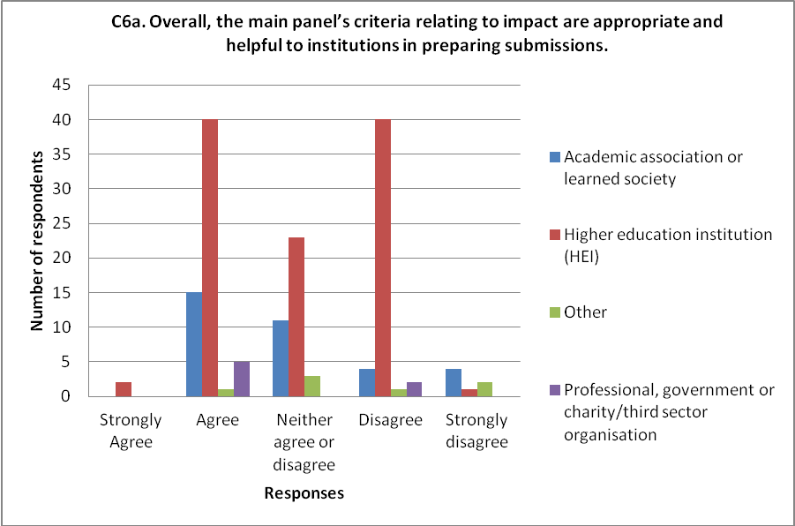
- Many responses requested more detailed guidance on the range of impacts and examples of types of evidence and indicators of impact from Main Panel C, in line with other main panels. This was seen as especially important as it is the first time impact has formed part of the REF. Other respondents either did not comment on this matter, or were in favour of the open approach taken by Main Panel C.

- Regarding the underpinning research, some respondents welcomed the panel’s wording and approach and recommended it is adopted by all panels. However, there was general concern expressed about how the eligibility of underpinning research would be assessed by sub-panels, with greater clarity requested on the evidence required for 2* quality.

- Further points raised on impact were as follow:

- There was some feeling that the guidance on public policy impacts was not wholly clear and consistent.
- Greater clarity was sought on the eligibility of impact that is beyond higher education but within education more generally.
- Some respondents requested clarification on the guidance on testimonial evidence for impact.
- There was some concern about breadth versus depth of impact, and the interpretation of the guidance. For example, an impact at a national level affecting millions of people would be regarded as equivalent to an impact which affects a small local community.
- Some respondents sought explicit guidance on the possibility that evidence may not have been collected or might no longer exist.
- Some respondents welcomed the extension of the timeframe for underpinning research for UOA 16: Architecture, Built Environment and Planning, while others did not see why such an exception had been made.
- There was some concern about the guidance that the specific contribution made by the submitting unit to an impact case study will be taken into account. This was seen as contrary to the other main panels where contribution is a threshold and it was suggested that this should be addressed in a consistent fashion across REF.
- Several respondents commented that guidance on the impact template lacks the level of detail provided by the other main panels. Further advice and guidance was sought on this.
- Many respondents welcomed the panel’s statement that the potential domain for an impact will be taken into consideration, and suggested this be adopted by the other main panels.
- There was broad agreement that the criteria definitions were clear.
- Some respondents identified the need for greater clarity on how panels will assess ‘reach and significance’ holistically.

Environment

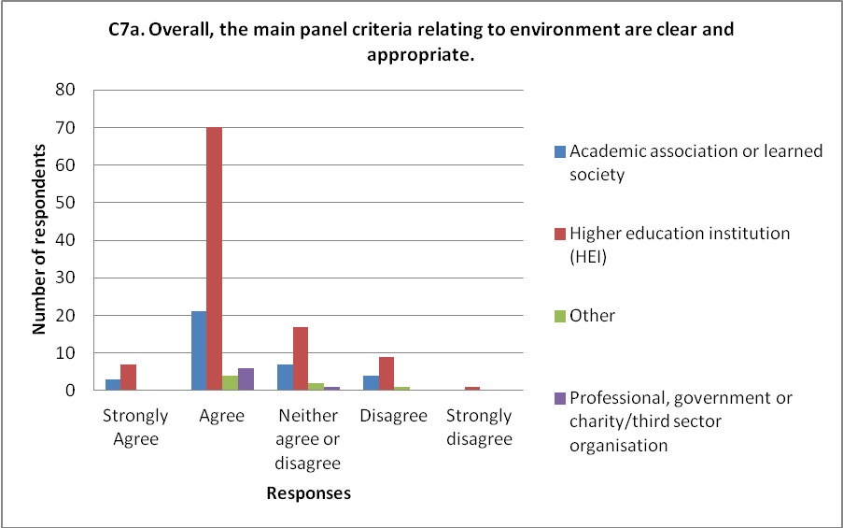

- There were significantly fewer comments on the environment section than on either the outputs or impact sections of the Main Panel C criteria. Around half of respondents expressed contentment with the proposals as they stood. A minority of responses welcomed the measures taken to standardise criteria.

- Many respondents noted that the approach of Main Panel C was inconsistent with other panels in not specifying how or if the various sections of the environment template would carry a specific weighting. There was no consensus about the best way to introduce a weighting.

- The following comments were raised:

- Some respondents were concerned about the presentation of non-cohesive units in the same submission and requested further guidance on this matter. Additionally, it was strongly felt that the aggregation of research environment data in such submissions would be difficult to assess meaningfully.
- Several respondents raised suggestions or concerns about the individual sections of the template, including some strongly expressed views that more information regarding support for equality and diversity could be sought, and seeking more information from a small number on the use of esteem factors.
- Many felt that the rationale for the additional quantitative data in UOAs 19, 25 and 26 was clear, although a significant proportion of respondents who mentioned this point sought further detail and clarity on the specific requirements.
- The definitions of vitality and sustainability were generally welcomed.

Working methods

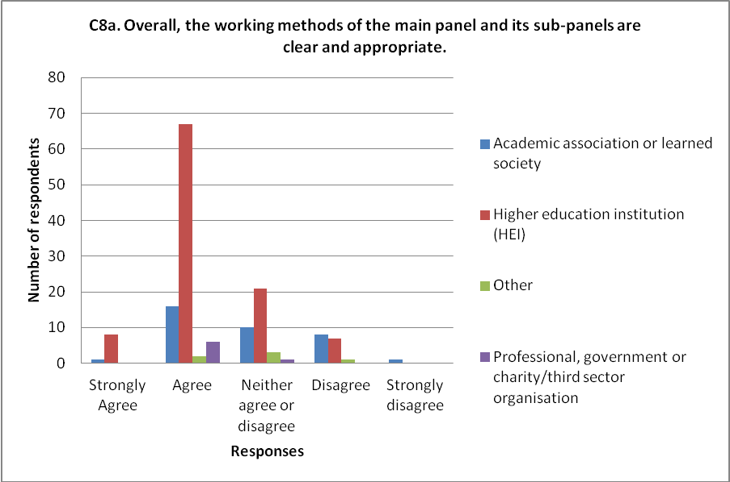

- Comments on Main Panel C’s draft working methods were broadly positive. The following specific comments and queries were raised:

- Cross-referral: concern was expressed that it is unclear which criteria will be applied where outputs are cross-referred, and that there may be disadvantage where citations are or are not used. Some respondents would prefer to see cross-referral used more widely, rather than by exception.

- Appointment and use of assessors: respondents broadly welcomed the use of assessors. However, it was felt that appointments should be made as early as possible, that the appointment process should be transparent, and that assessors should play a full role in the assessment process.

- Expertise: it was felt that sub-panels should ensure that:

  - appropriate expertise is available to assess work at the boundaries, work which is interdisciplinary and multi-disciplinary
  - sub-panels can cope with the workload, and that sub-panels should ensure sufficient assessors are appointed to compensate for the fact that some sub-panels cover a broader range of disciplines than in RAE2008.

- Respondents generally welcomed the presentation of the overall quality profiles in steps of 1 per cent.

Responses to Main Panel D’s statement of criteria

- There were 185 respondents to Main Panel D’s statement of criteria.

Consistency across sub-panels and consistency of assessment

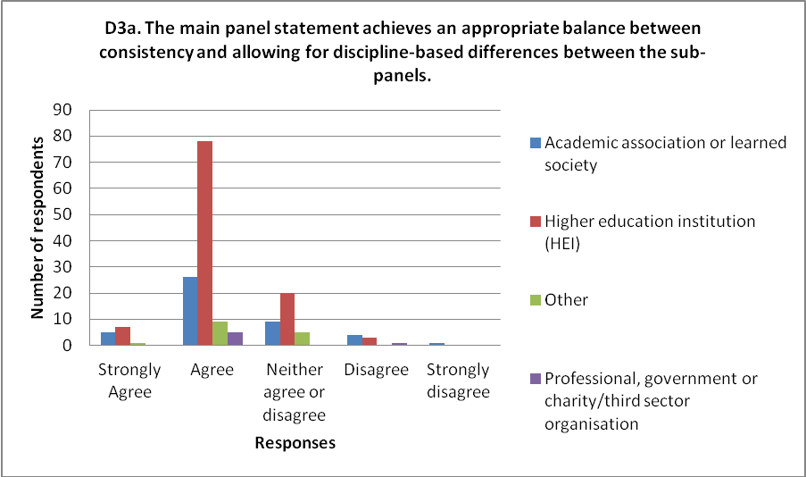

Submissions and UOAs

- Most respondents were content with the proposals for multiple submissions. However, a significant minority felt that the approach needed to be consistent across all main panels, with a range of views as to what the consistent approach should be. A small number felt the proposals were vague and contradictory when read against ‘guidance on submissions’. Some respondents were concerned about the timing for requesting multiple submissions, and a few requested more clarification on the decision-making process and who will be involved.

- A number of specific comments were received on the UOA descriptors.

Outputs

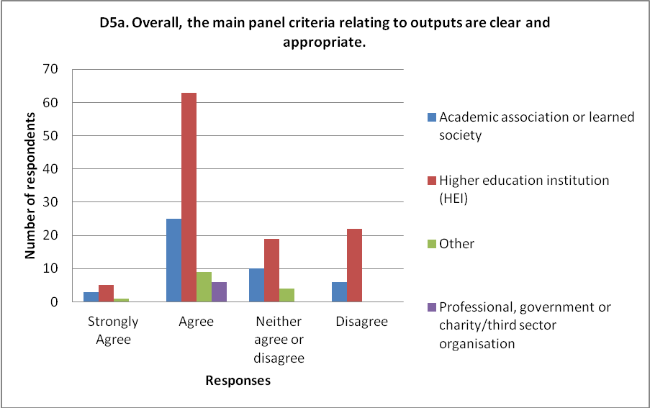

- Around half of respondents on types of outputs explicitly welcomed the inclusive definitions and types of research listed as well as the stated intention to judge all outputs entirely on academic merit regardless of the medium or location of publication. A significant number were concerned with the lack of detail on the approach to scholarly editions of texts and edited collections of essays, in particular whether the eligible output is the whole collection, or just that part of it authored by the editor.

- The following issues were raised on co-authored outputs, with mixed feedback on each:

- Co-author contribution statement: a small number considered that this requirement is too vague, adds to institutional burden, lacks transparency and/or discriminates against collaborative work. If it remains, clarification was sought on the information requested.
- A significant number queried the ban on quantitative description in the co-author statement. It was felt that there are circumstances in which such information could aid a panel’s judgement, and that submissions should be able to include it where they believe it to be relevant.
- Many of the respondents welcomed the opportunity to list an output more than once in the same submission. A small number, however, expressed a preference for a limit to the number of times an output could be listed within a single submission.

- Further key comments on outputs were:

- A significant minority of respondents felt that the criteria and level definitions did not adequately reflect the characteristics of practice-led, practice-based, or ‘creative’ research.
- Some respondents felt that Main Panel C and Main Panel D should adopt a consistent approach to level definitions, with most preferring Main Panel C. A small number of respondents recommended reviewing the Main Panel B level definitions for indicators of quality that could be added to this section.
- Many respondents sought a clearer distinction between 3* and 2* activity. A small number felt there should be more clarification of the 3*/4* boundary.
- More detail was sought on what could be submitted as part of a statement (for additional information on outputs) and a portfolio, and what the relationship is between them. A small number strongly questioned the rationale for appearing to limit the 300 word commentary to ‘practice-based outputs’, considering this to be an artificial distinction.
- Some concerns were raised about the guidance on overlapping outputs which were thought to disregard the cumulative nature of research in the humanities.
- A number of respondents queried the status of publications that were first available online prior to 2008, but given a 2008 journal date. It was suggested that outputs appearing in another form prior to 2008 should be eligible, where they were not submitted to the RAE.
- Nearly all respondents who commented on double-weighting welcomed the arrangements, in particular the concept of the ‘reserve’ item. A significant minority suggested that there should be consistency of approach between Main Panel D and Main Panel C (and indeed across all main panels), with most favouring the approach of Main Panel D.
- Further clarification on the characteristics of a double-weighted output was sought from most respondents.
- A small number of respondents queried whether the waiver for Sub-panel 28: Modern Languages and Linguistics regarding an abstract for outputs in a language other than English should be applied to other sub-panels.
- Of those that commented on citation data, nearly all welcomed the panel’s approach.

Impact

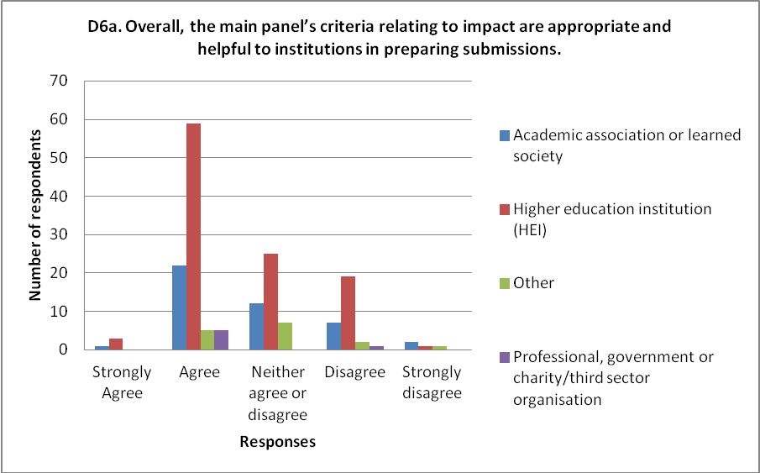

- A significant number of respondents acknowledged the helpfulness of the impact criteria and list of examples. A number noted that it would be important for the panel to be flexible in the assessment to capture the wide variety of impact covered by the disciplines served by Main Panel D. Some specific comments in relation to the examples of impact were raised.

- In terms of the evidence of impact, a significant number expressed concern regarding an institution’s ability to be able to evidence its impact, and whether that evidence would be seen as robust. This included a number of responses that noted that the distinction between ‘dissemination’ and ‘impact’ was not made clear in the criteria.

- The majority of comments on the guidance on underpinning research questioned how the quality level of underpinning research would be determined, noting that this was not clear from the criteria. Clarity was also requested as to whether all underpinning research would be assessed. A small number of responses questioned the panel’s clarity on when underpinning research is judged to have taken place.

- Further points raised by a small number of respondents on impact were:

- the current formulation of the template is too restrictive; a more general template would be favoured
- clarification on the role of the template in the assessment of impact
- clarification on the holistic assessment of the impact criteria
- the requirement that units under 14.99 FTE submit 2 case studies may potentially disadvantage smaller departments
- the impact element may also disadvantage departments with a high number of Early Career Researchers, or recently established departments.

Environment

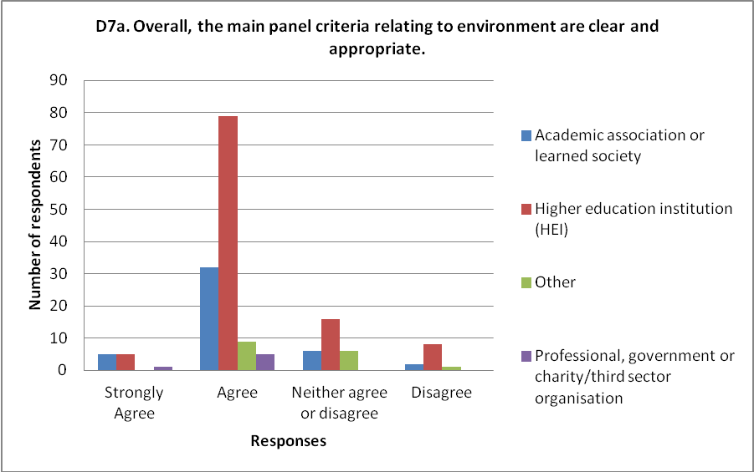

- A significant proportion of respondents on the environment section was content or had no comment.

- The most frequently raised issue was the weighting of the five elements of the template, and whether judgement should be holistic or based solely on the scores for the elements. There was no consensus over which approach was preferable, with some strong views expressed for both arguments. There was some feeling, and consequent request for clarification, that it was unclear at present as to how the overall profile for the environment was to be determined.

- Further comments raised by several respondents on the template were:

- the challenge of collating and reporting strategies from multiple departments which had reported separately in the previous RAE, and which would now be incorporated into a single submission
- there should be a requirement to specify policy on sabbatical and other leave
- destination data for research students should be requested as an output metric of excellence in the training of graduate students
- clarification on the eligibility of professional doctorates, DBAs and PhDs by publication and portfolio
- the gap on reporting of completed research students between RAE2008 and REF2014 should be explained or the data be included in submissions
- guidance on how confidentiality of equality and diversity might be maintained in small units
- clarification on income streams other than those returned through HESA and on the status of different kinds of income
- a stronger statement on how environment responds to, and allows for, contributions of staff across HEIs, and clarification on whether esteem indicators are part of the environment assessment
- further detail on how data provided would be used, and the value of metric data in combined UOAs which comprised several distinct units.

- Several respondents requested further explanation of ‘vitality’ and ‘sustainability’ although others expressed support for the wording provided.

Working methods

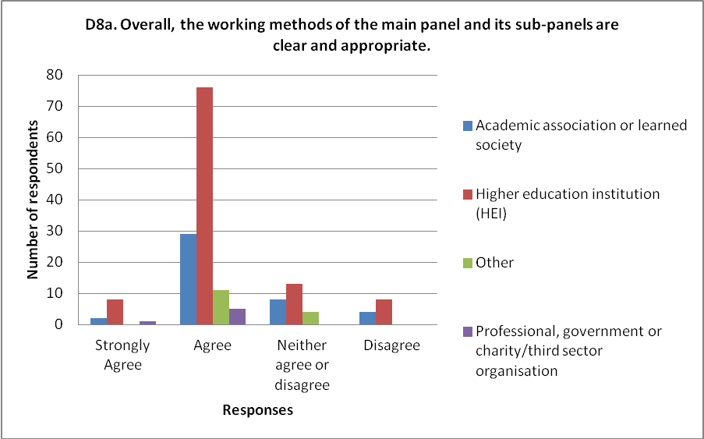

- Around a third of respondents on the working methods either commented on the clarity and appropriateness of the wording, welcomed the commitment to identifying areas of excellent research and the decision not to seek citation or bibliometric data, or had no comments to make.

- Half of those commenting raised issues regarding the appointment and use of additional assessors. The need to appoint a sufficient number of assessors to meet the expertise and workload requirements of the panels was raised, as was the need for induction and training of assessors. Further detail was sought on the process and timing of appointments, and on the role of assessors. A number of respondents expressed their support for the use of assessors, in ensuring wider coverage of the disciplines and to cope with the workload.

- Many of those commenting expressed concern at the lack of detail and vagueness of the proposed level of assessment and proportion of outputs to be examined. There were requests for more specific and quantified information on how sub-panels would apportion the workload and undertake the assessment.

- Further comments on the working methods were:

- clarification on the proposed calibration exercise
- further detail on the proposed arrangements for assessing cross-referred and interdisciplinary work
- further clarity on the role of user members/assessors.

Annex A Summary of the four workshops held for research users

Introduction

- During the consultation on the draft panel criteria, four workshops were held for individuals and organisations outside the higher education sector that engage with and/or make use of research. The workshops aimed to gather feedback on the proposed criteria for assessing impact. This annex provides a high-level summary of the key points emerging from across the four workshops. More detailed points from the workshops were reported to the main panels, for them to consider alongside the consultation responses.
- One workshop was held for users of research relevant to each main panel. The sub-panels put forward suggestions for potential workshop participants. A wide range of individuals relevant to the disciplines covered by each main panel were invited to attend. Participants included individuals from:
- Government departments, public service providers, public bodies and agencies (including health services and regulation, animal health, the environment, economic and monetary policy, intelligence, defence, international relations, national museums, galleries and libraries, public service broadcasting, arts and heritage funding, the built and natural environment, industrial relations, weather services, communications regulation, food standards, analytical services within Government, the Scottish Government and Welsh Assembly Government).
- Industry (including from the pharmaceutical, food, oil and gas, power systems, ICT, telecommunications, publishing, finance, consumer goods, transport, design, planning and engineering industries).
- Charities, NGOs and third sector organisations (including those concerned with medical research, health services, poverty and justice, child protection, social well-being, housing, international development, education, wildlife conservation, heritage conservation, the visual arts, volunteering and public participation).
- The professions and professional associations (including those concerned with teaching, nursing, accountancy, management and leadership, social work, children’s services, the clergy and journalism).
- The format of each workshop included plenary presentations to introduce the broad framework and criteria for impact. Participants were then divided into break-out groups to discuss certain aspects of the criteria in more detail.

Key points of feedback

- There was broad consensus at the workshops on the value of acknowledging and highlighting the impact of research, and participants generally supported the introduction of ‘impact’ as a significant element of research assessment.

Range of impacts and assessment criteria

- Participants generally found the range of impacts and the assessment criteria provided in the draft documents clear and appropriate. Participants at the Main Panel C workshop highlighted the likely value to the sector in providing (non-exhaustive) examples of impact. A number of specific points were made about refining the examples listed.

- A number of more general points were also raised, including:

- recognition that impacts are often dependent on factors beyond the institution’s control
- it should be made clear that ‘reach’ does not equate to a geographic scale, and that impact occurring anywhere in the world is eligible (so that an impact within one part of the UK or other country may attain the highest rating)
- the value of positive impacts from negative outcomes
- more clarity is needed on impact ‘extending significantly beyond the submitting HEI’
- impact may be on or through ‘intermediary’ users of research, or the ultimate beneficiaries and/or end users (many participants identified themselves as intermediaries).

- Participants discussed impacts arising from public engagement. It was felt that clear guidance would need to be provided to institutions on making the link between the engagement activity and high-quality research. A number of specific suggestions were made on the draft criteria to make clearer the guidance on evidencing public engagement impacts.

Evidencing impact
- Across the workshops, participants identified a number of issues they anticipate that institutions will face in providing evidence of impact, including:

- Impact can often occur incrementally, which raises challenges in tracing the links in the chain.
- The often collaborative nature of research underpinning impact raises issues around ‘attribution’ in case studies.
- Some users of research (including policy makers as well as other institutions such as museums) often do not directly reference the research they have used. Impacts on these users would therefore be more difficult for institutions to identify where they do not have an ongoing relationship with the users. There would also be a need for ‘user testimony’ as evidence, where the research is not cited.
- Impacts involving the prevention of a detrimental change could be more difficult to evidence than impacts focusing on positive changes.
- In some areas, impacts are diffuse and/or cannot be measured in a quantifiable way (for example, informing thinking or public understanding). These raise challenges around tracing the paths from research and in providing evidence. Some suggested tracing such impacts by focussing on where the diffusion of ideas becomes ‘visible’ (for example, in public debate or the media).
- Some participants noted they value impact from researchers as well as from research – experts or advisors would be expected to draw on a wider body of knowledge than their own research or specialism.
- Generally, participants felt there would be challenges in collecting evidence for the first REF exercise – particularly as it is retrospective.

- In raising these issues, participants were keen that institutions should be encouraged to submit all kinds of impacts including those that may be more challenging to evidence. Institutions should not avoid these examples in favour of impacts that may be of less value but are easier to evidence.

- The issue of submitting confidential information within case studies was considered at the workshops for Main Panels A and B in particular. While participants recognised there may be some cases where organisations might be unwilling to release commercially sensitive information, in general they would be willing to do so because:
- Case studies are retrospective, and the information is no longer sensitive by the time the impact is ‘mature’ enough to be suitable for a case study.
- Companies would want to maintain positive relationships with the HEIs they work with.
- A separate process might be needed for highly confidential impacts, but these were anticipated to be small in number. For these cases, participants suggested the material should be provided only to specific individuals on a panel who have appropriate clearance.

User involvement

- Participants discussed the role of user organisations in being asked by HEIs to contribute evidence, and in corroborating impact case studies. Participants recognised the importance of their contribution to this process and requested that further, specific information and guidance should be provided to the user community. The guidance should explain the nature of these roles, what specifically is expected of them, the timescales concerned, and guidance on issues of confidentiality and conflicts of interest.

- Some public sector bodies that use a range of research from numerous institutions noted they are likely to receive many requests for information and wished to consider how best to manage these.

- Participants generally supported the inclusion of the ‘impact template’ in addition to case studies, to provide a useful overview and support a culture of engagement. Participants recognised this as a two-way process, with institutions making research expertise and insights readily accessible and users providing evidence of engagements, learning from each other in the process.

